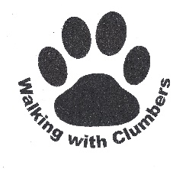
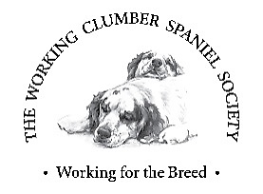

Clumber Spaniels
are having a
Picnic in the Park
at the Hardwick Kennels, Clumber Park
on Sunday 23rd June 2024
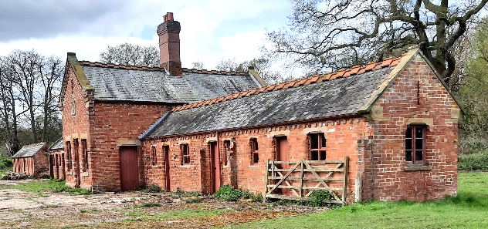

Everybody is invited - You don’t have to own a Clumber
Come and meet the breed and find out more about their
historic links with Clumber Park
Gates Open at 12 midday

This event is being organised by Walking with Clumbers, the Working Clumber Spaniel Society and the Clumber Spaniel Club, in partnership with the National Trust. This is a unique opportunity to visit the Kennels, not normally open to the public, where the last Clumbers to be bred in the Park were kept.

Walks to the Kennels

10.30 am Clumber Walk: Walking with Clumbers members walk will start at Central Bark cafe, cross clumber bridge, round the lake to the Lake Brew caravan, the Park Inn, and toilets. It will then take the road through Hardwick village to the kennels. Joining this walk requires prior registration.

11.30 am and 12.30pm: Guided Walks for all visitors from Central Bark Café and the Cowpastures car park to the Kennels. The route takes about 30 minutes, and goes along the lake path to the Lake Brew caravan, the Park Inn, and toilets. There is a short cut which goes up a steepish hill section but misses the facilities at Lake Brew and the Park Inn.

For further information about these walks and other events on the day please email:
walkingwithclumbers@gmail.com

Activities at the Kennels
Working Clumber Spaniel Society Demonstration: Clumber Spaniels were originally bred to flush game in the thick undergrowth of Sherwood Forest during the 18th century, although more recently they have also been used to retrieve. Members of the Society will be on hand to answer any questions about working dogs.
Demonstration by The Clumberjacks Obreedience Team who brought the unique style of the Clumber Spaniel to this year’s Crufts Final, and showed that any breed can do well in competitive obedience.

A Scurry which is a fun way of encouraging your dog to retrieve. Dogs are sent for a retrieve a dummy against the clock. This fun event will be open to all dogs.

The Park, The Dukes, and their Dogs: There will be a short talk and a static display on the origins of the breed and their links with the Park, in the Walking with Clumbers gazebo.

Grooming Demonstration in the Clumber Spaniel Club gazebo. A chance for Clumber Spaniel owners to have their dog’s ‘Hobbit Feet’ become neat feet. The Club will also be promoting the breed Rescue and Rehoming Scheme.

Competitions: Test your knowledge about Clumber Spaniels, their history and links to Clumber Park; and have a go at guessing the number of biscuits in the jar.

Programme
Please note that times may be subject to change

10.30 | Walking With Clumbers Lakeside Walk: Joining this walk requires prior registration
11.30  &  12.30 | Guided Walks to the Kennels from Central Bark Café and the Cowpastures car park through the wood to the Hardwick Kennels
12.00 | Gates Open at the Hardwick Kennels
13.00 | The Dukes and Their Dogs: Talk on the history at the Walking with Clumbers gazebo.
13.30 | Demonstration by The Clumberjacks Obreedience Team
14.00 | Clumber Spaniel Grooming Demonstration: at the Clumber Spaniel Club gazebo
14.30 | Working Clumber Spaniel Society Demonstration
15.00 | Group Photo in front of the Kennel buildings
16.00 | Event Closes and visitors will be asked to leave the field

Any money raised will be donated to Clumber Park to support the project at Clumber Bridge to create bollards in the shape of Clumber Spaniels, to stand guard and help protect the Grade II listed monument for future generations.

